Page 1: The Title Page

Manuscript Type: ORIGINAL ARTICLE

Title: Basic characterization of heat shock protein 70 genes HSPA2 and HSPA8 from the Japanese quail, Coturnix japonica

Authors: Kei HANZAWA,¹ Takashi SHIINA² and Autthaporn S. TAWEETUNGTRAGOON³

Institute, address, country: ¹Department of Animal Science, Tokyo University of Agriculture, Atsugi, ²Department of Molecular Life Science, Tokai University School of Medicine, Kanagawa, Japan; and ³Gibthai Company Limited, Bangkok, Thailand

Correspondence: Kei Hanzawa, Department of Animal Science, Tokyo University of Agriculture, Atsugi, Kanagawa 243-0034, Japan. Email: khanzawa@nodai.ac.jp
Title: Only head of the title and proper nouns should be written in capital letters and no period should be put at the end.

Authors: The first and last names of each author should be written in full. A middle name should be written as the initials followed by a period.

Institute, address, country: Department and University / Research organization, City / Prefecture and area, and Country should be given. They should be written in italics. Numbers should connect the institute with each author.

Correspondence: Name, institute, address, ZIP code, country, and e-mail address should be given.

Page 2: ABSTRACT & Key words

ABSTRACT
We have identified two members of the heat shock protein (HSP) 70 family from the Japanese quail, Coturnix japonica. - - - - - - - - - - - - - - - - - - - - - - - - - - - - - - - - - - - - - - - - - - - - - - - - - - - - - - - - - - - - - - - - - -. Taken together, the data suggest that CjHSPA2 and CjHSPA8 encode orthologs of HSPA2 and HSPA8 with the notable difference that CjHSPA2 and CjHSPA8 are heat shock-inducible genes, whereas HSPA2 and HSPA8 are constitutively expressed in a heat shock-independent manner.

KEYWORDS
gene structure, heat shock protein 70, HSPA2, HSPA8, Japanese quail

ABSTRACT: should be written within 200 words or less on page 2.

Up to five Key words and/or phrases (consisting of less than five words) can be written at the end of the abstract, and arranged in alphabetical order.

Page 3 and following pages: text, acknowledgements, references, figure legends, figure(s) and table(s)

1 INTRODUCTION

Proteins in the heat shock protein 70 family - - - - - - - - - - - - many proteins (Bradley-Johnson, 1994). - - - - - - - - - - - - - . The cytoplasm (CY) and endoplasmic reticula (ER) groups are - - - - - - (Beers & De Bellis, 2002). Seven CY genes have been identified in the human genome (Rutter et al., 2003). - - - - - - - - - - - --. Beers and De Bellis (2002) already reported in - - - - - - - chickens (Gallus gallus, or Gg).
CD1 molecules play an important role in the immune system, presenting lipid-contain - - - - - - (Beers & De Bellis, 2002; Rutter et al., 2003). CD1 transcription is strong in chicken lymphoid tissues, particularly bursa and spleen (Miller M. et al., 2008, unpublished data). - - .
Reference citation in the text. References in text should be written as surname of the first author and published year in parenthesis. The author's initial should not be included.

If there are two authors use ‘and’: Smith and Jones (2001); but if cited within parentheses use ‘&’: (Smith & Jones, 2001).
Three to five authors (first occurrence): Waterman, Roman, and Rock (1993) and (Waterman, Roman, & Rock 1993)
Three to five authors (subsequent occurrence): Waterman et al. (1993) and (Waterman et al., 1993)
More than five authors: Smith et al., (2001), (Smith et al., 2001)

Plural references in a place should be divided by semicolons and written in alphabetically by name.

*If references could not be distinguished by the above-mentioned rule of citation (Author(s) and published year), put the alphabet behind the published year depending on the order that appeared in the text.

Reference to unpublished data and personal communications should not appear in the list but should be cited in the text only.

Unit.
5 ml, 5 mol/L, 5%, 5ºC, 10,000×g, 5 hr, 5 min, 5 sec, 17:00 hours (the time),
p < .05, Means ± SE, Means ± SEM, Means ± SD

2 MATERIALS AND METHODS

2.1 Animal care and nucleic acid isolation
The management of Japanese quail and all procedures in the present study were performed according to the Animal Experimental Guidelines for Tokyo University of Agriculture. - - - - -

2.2 Amplification of full-length cDNA sequences for three quail HSP70 genes
Complete cDNA sequences for CjHSPA2 and CjHSPA8 were amplified using - - - - - - - - - - -

3 RESULTS

3.1 Isolation and sequence of quail HSP70 family cDNA
We identified cDNA sequences that - - - - - - - - - -. Therefore, mammals and avian belong to different clusters, with the exception that, at the amino acid level, CjHSPA8 is more similar to HsHSPA8 than it is to GgHSC70 (Figure 1). - - - - - - - Figure 2 shows the results of -----.
Accordingly, the conceptual translations of the quail HSP70 genes show a high level of sequence identity to chicken and human proteins.
[Figure 1]

A place to insert Figure and/or Table should appoint in text.

4 DISCUSSION

4.1 CjHSPA2 expression is elevated in response to heat shock treatment
We next asked if any of the quail HSP70-related genes reported here respond to heat shock treatment. - - - - - -

5 CONCLUSION
Our knowledge regarding avian MHC has increased

ACKNOWLEDGMENTS
This work was supported by Grant-in-Aid for Scientific Research from -----
If the work is supported by any grants, ACKNOWLEDMENTS should be written.

REFERENCES
Example of reference with 2 to 7 authors
Beers, S. R., & De Bellis, M. D. (2002). Neuropsychological function in children with maltreatment-related posttraumatic stress disorder. The American Journal of Psychiatry, 159, 483–486. https://doi:10.1176/appi.ajp.159.3.483
Ramus, F., Rosen, S., Dakin, S. C., Day, B. L., Castellote, J. M., White, S., & Frith, U. (2003). Theories of developmental dyslexia: Insights from a multiple case study of dyslexic adults. Brain, 126(4), 841–865. https://doi:10.1093/brain/awg076

Example of reference with more than 7 authors
Rutter, M., Caspi, A., Fergusson, D., Horwood, L. J., Goodman, R., Maughan, B., … Carroll, J. (2004). Sex differences in developmental reading disability: New findings from 4 epidemiological studies. Journal of the American Medical Association, 291(16), 2007–2012. https://doi:10.1001/jama.291.16.2007

Online article not yet published in an issue style
Beers, S. R., & De Bellis, M. D. (2002). Neuropsychological function in children with maltreatment-related posttraumatic stress disorder. The American Journal of Psychiatry, https://doi:10.1176/appi.ajp.159.3.483

Book edition
Bradley-Johnson, S. (1994). Psychoeducational assessment of students who are visually impaired or blind: Infancy through high school (2nd ed.). Austin, TX: Pro-ed.

For a chapter in a book or entry in a reference book, use the following formats
Author, A. A., & Author, B. B. (1995). Title of chapter or entry. In A. Editor, B. Editor, & C. Editor (Eds.), Title of book (pp. xxx-xxx). Location: Publisher.
Author, A. A., & Author, B. B. (1993). Title of chapter or entry. In A. Editor & B. Editor (Eds.), Title of book (pp. xxx-xxx). Retrieved from http://www.xxxxxxxxxxx
Author, A. A., & Author, B. B. (1995). Title of chapter or entry. In A. Editor, B. Editor, & C. Editor (Eds.), Title of book (pp. xxx-xxx). doi:xxxxxxxxxx

Entire book, print version
Shotton, M. A. (1989). Computer addiction? A study of computer dependency. London, England: Taylor & Francis.

Electronic version of print book
Shotton, M. A. (1989). Computer addiction? A study of computer dependency [DX Reader version]. Retrieved from http://ebookstore.tandf.co.uk/html/index.asp
Schiraldi, G. R. (2001). The post-traumatic stress disorder sourcebook: A guide to healing, recovery, and growth [Adobe Digital Editions version]. doi:10.1036/0071393722

Electronic-only book
O'Keefe, E. (n.d). Egoism & the crisis in Western values. Retrieved from http://www.onlineoriginals.com/showitem.asp?itemID=135

Electronic version of republished book
Freud, S. (1953). The method of interpreting dreams: An analysis of a specimen dream. In J. Strachey (Ed. & Trans.), The standard edition of the completed psychological works of Sigmund Freud (Vol. 4, pp. 96-121). Retrieved from http://books.google/books (Original work published 1900)

Electronic material
National Center for Biotechnology Information (NCBI). (1999). Nucleotide–nucleotide BLAST (blastn) [homepage on the Internet]. National Center for Biotechnology Information, Bethesda, MD; [cited 13 December 2002]. Available from URL:http://www.ncbi.nlm.nih.gov/blast/

Ph.D. Thesis.
Suzuki, Y. (2016). Study on the physiological functions of two endocrine factors derived from the liver, ANGPTL8 and Chemerin, in Ruminants. Ph.D. Thesis, Tohoku University, Sendai, Japan.

Patents: In text, give the patent and the issue date (not application date) of the patent. In the reference list entry, include the investor(s) to whom the patent is issued and the official source from which the patent information can be retrieved.
Reference list entry: Smith, I. M. (1988). U.S. Patent No. 123,445. Washington, DC: U.S. Patent and Trademark Office.
All the cited papers in the text should be listed in REFERENCES.
All the papers in REFERENCES should be cited in the text.
The Publication Manual of the American Psychological Association (6th edition) of referencing is used.
References should be listed in alphabetical order of the first author's surname. Plural references by the same author should be listed by the chronological order. Plural references by the same author published in the same year should be listed in alphabetical order of the last name of second author.

SUPPORTING INFORMATION
Additional Supporting Information may be found online in the supporting information tab for this article.

Figure legends
FIGURE 1 Morphological profiled on erythroid cells from equine peripheral blood during incubation in a two phase liquid culture system. Im Ebl: immature erythroblasts, M Ebl: mature erythroblasts, D Ery: denucleated erythroid cells. Values are expressed as mean ± SE

FIGURE 2 Changes in percentage of haemoglobin containing cells on erythroid cells from equine peripheral blood during incubation in a two phase liquid culture system. Im Ebl: immature erythroblasts, M Ebl: mature erythroblasts, D Ery: denucleated erythroid cells. Values are expressed as mean ± SE

Legends should be self-explanatory and typed on separate pages.
The legend should incorporate definitions of any symbols used and all abbreviations and units of measurement should be explained so that the figure and its legend are understandable without reference to the text.

Examples for Figure and Table (Prepare on separate pages from the text)

FIGURE 1

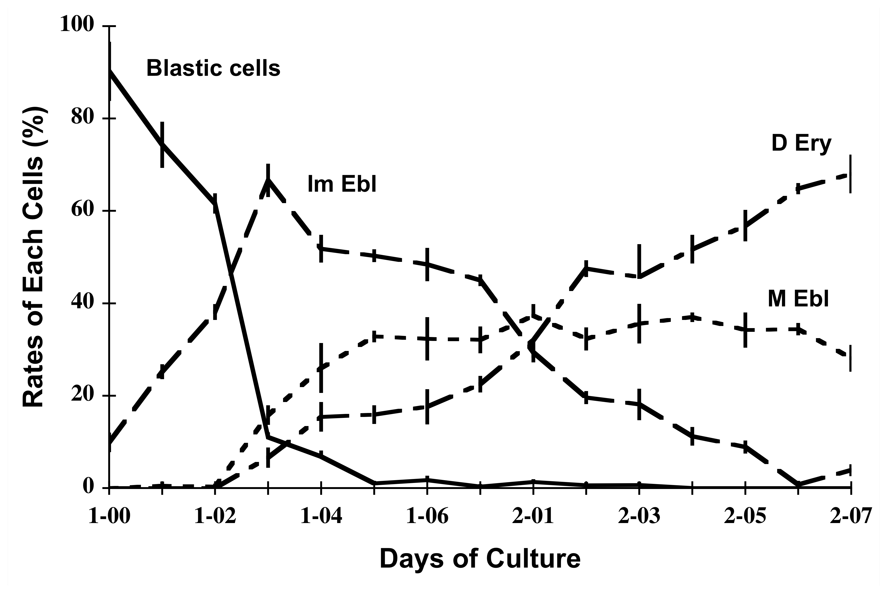
Each figure should be supplied as a separate file, with the figure number incorporated in the file name. For submission, low resolution figures saved as .jpg or .bmp files should be uploaded, for ease of transmission during the review process. Upon acceptance of the article, high-resolution figures (at least 300 d.p.i.) saved as .eps or .tif files should be uploaded. Digital images supplied only as low-resolution files cannot be used.

TABLE 1 Changes in percentage of blood group antigen expressed cells on erythroid cells from equine peripheral blood during incubation in a two phase liquid culture system

Blood System | A | C | D
Factor | Aa | Ca | Dk | Dl
Days of culture
0 | 0 | 0 | 0 | 0
1 | 10.5 ± 3.3ª | 7.1 ± 3.3ª | 0 | 0
2 | 19.9 ± 3.3^{ab} | 17.2 ± 5.1^{ab} | 5.3 ± 5.1ª | 3.2 ± 2.5ª
3 | 37.7 ± 2.4^{b} | 31.8 ± 3.9^{b} | 15.4 ± 4.2ª | 12.5 ± 2.3ª
4 | 56.4 ± 4.1^{c} | 54.5 ± 2.4^{c} | 21.1 ± 1.4^{ab} | 18.0 ± 3.5^{ab}
5 | 91.5 ± 1.5^{d} | 78.3 ± 4.6^{d} | 52.2 ± 2.1^{c} | 51.0 ± 5.4^{c}

Values are expressed as mean ± SE. Different letters indicate significant differences (a < b < c < d, p < .05).

Tables should be made using Microsoft-Excel.
The style and format of the table should be according to the instructions for authors and the recent issues.
Abbreviations used in a table must be defined in that table.

